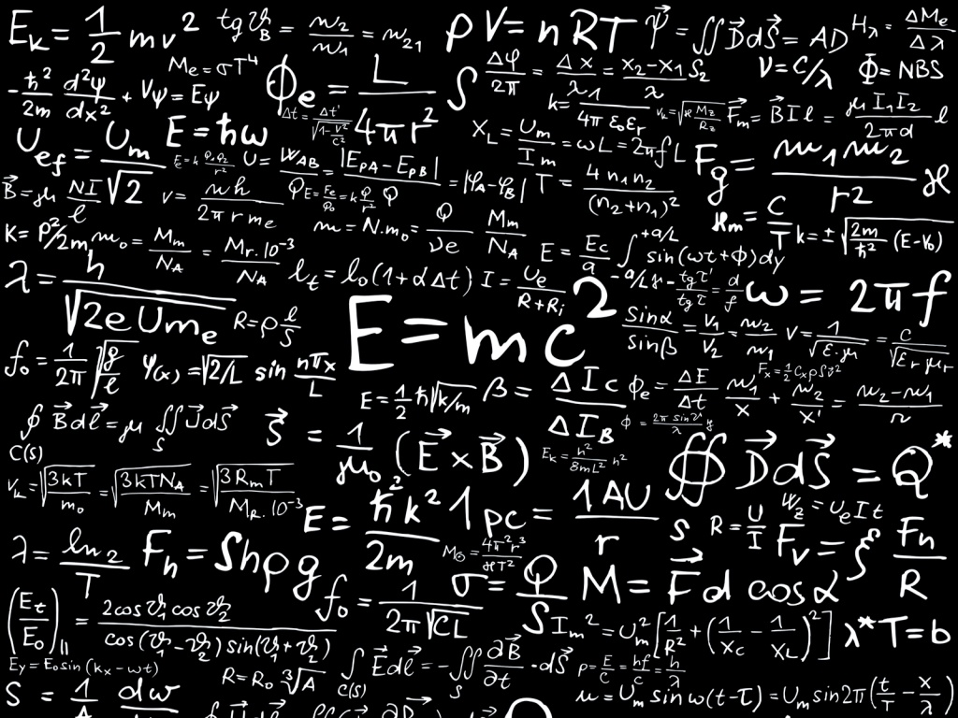
Physics Department Colloquium
Dr. Alexandros Gerakis,
Princeton Plasma Physics Laboratory
Measuring gases and nanoparticles with coherent Rayleigh-Brillouin Scattering
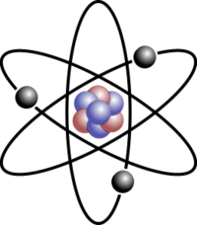
In this talk, an overview of the work done at the laboratory for plasma nanosynthesis at Princeton Plasma Laboratory will be given with special emphasis to the laser diagnostic techniques employed for the in situ detection of arc-produced nanoparticles. In particular, emphasis will be given on the development and application of a new laser diagnostic for the in situ detection of large molecules and nanoparticles, termed coherent Rayleigh-Brillouin scattering. This four wave mixing diagnostic technique relies on the creation of an optical lattice in a medium due to the interaction between polarized particles and intense laser fields. Through this interaction, we can detect the temperature, pressure, relative density, polarizability and speed of sound of a gas and gas mixture. This diagnostic was already successfully demonstrated in atomic and molecular gaseous environments, where the different gas polarizabilities and pressures were successfully measured. We are currently conducting measurements with large molecules and nanoparticles, the results of which will be presented in this talk.

Date: Tuesday, October 3, 2017
Time/Place: 12:30 PM / SCP 317

