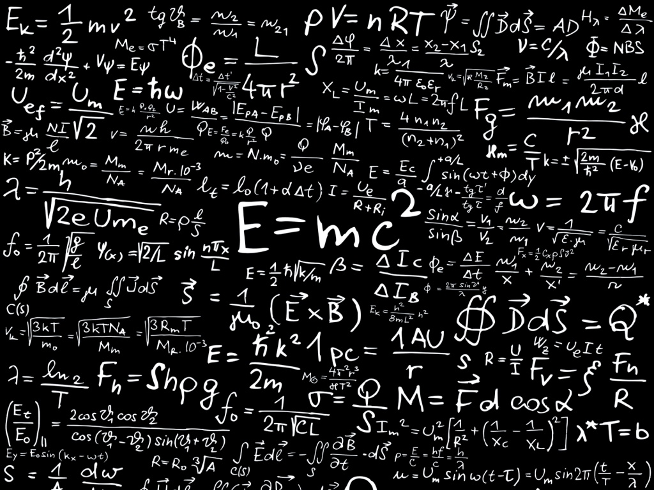
Physics Department Colloquium
Friday, September 15, 2017
Dr. Mike Kalb
Introduction to String Theory
String Theory is an explanation of physical reality in terms of a fundamental particle that is not point-like, but rather extended as a thin filament of a very small but finite length. We will see how String Theory fits into the historical development of physics, and how it aims to provide a unified description of all fundamental interactions. We go on to consider the properties of strings as relativistic objects. Importantly, experimental verification and predictions of String Theory shall also be examined. This discussion is the introductory talk of a seminar series presented by the author at TCNJ over the fall semester.
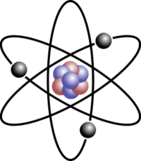
Date: Friday, September 15, 2017
Time: 12:30 PM
Where: Science Complex, P-317

